Name: Harshalk

Std: TYBSCIT

Roll no: 16

Subject: DMBI

(Practical No 7)

Signature:

Practical 7 – Data Analysis using Time Series Analysis

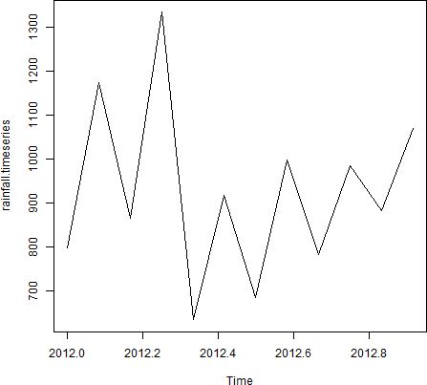



Name: Harshalk

Std: TYBSCIT

Roll no: 16

Subject: DMBI

(Practical No 8)

Signature:

Practical 8

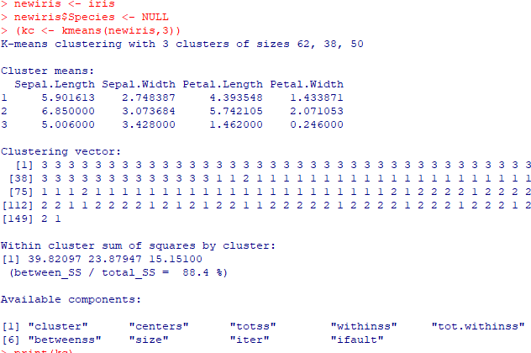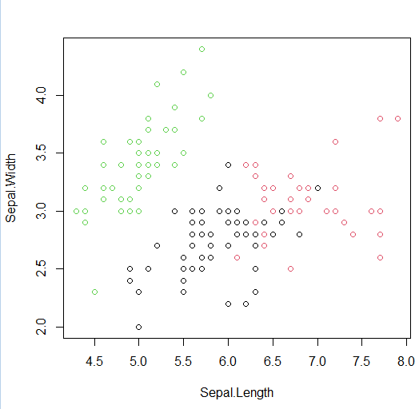

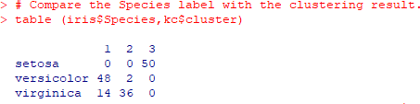

Name: Harshalk

Std: TYBSCIT

Roll no: 16

Subject: DMBI

(Practical No 9)

Signature:

Practical 9

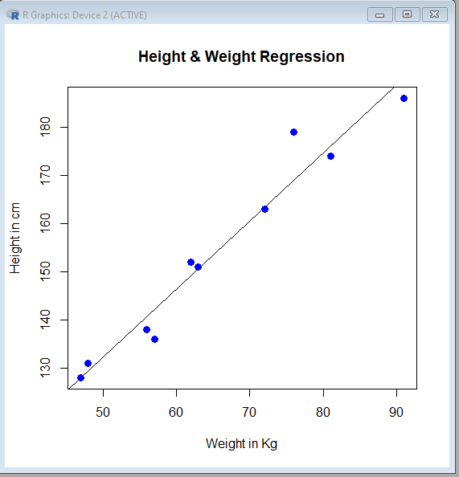

Name: Harshalk

Std: TYBSCIT

Roll no: 16

Subject: DMBI

(Practical No 10)

Signature:

Practical 10 Implementation of Decision-Tree using R-tool

Install.packages(“party”)

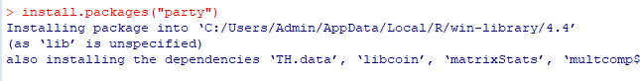

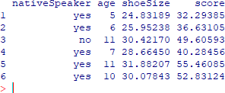print(head(readingSkills))

